Capstone Project Report



Smart Waste Management System
Submitted to- Dr. Manjot Kaur
UID- 28925

Submitted by
- Subhash Suthar (12215865)
- Chetak Mungalpara (12207641)
- Krishna Pradhan (12224021)
- Vishal Biswakarma ( 12206477)
- Gaurav Kumar Sahu(12216579)
- Shashi Kant Kumar (12214125)
1. Introduction
Population in India is growing at a rapid pace and this has made waste management a very important issue in urban areas limited infrastructure, growth and consumerism. Manual separation is done in a traditional way ineffective, hazardous, and subject to human error, and thus excessive landfills, environmental pollution, and higher level of greenhouse gases. This project presents a full-scale AI-based system that is able to identify and isolate trash into pre-defined classifications but offers real time data analytics to assist municipal decision making. The IoT, machine learning, and automation interconnection is the solution to the current sustainability objectives enhances ground ground level operation.

1.1 Objective of the Project

The major objectives are:
Create a scalable, low cost, intelligent waste sorting system with the help of AI. Reduce human intervention and risk-related to health due to manual segregation. Implement live tracking and factual decision making to cities. Recycling Not all waste is the same and this should be promoted by ensuring that the waste is properly categorized at the point of origin. Empower predictive waste trend analytics in city planning and sustainability programs. Minimize emission of carbon by optimization of waste collection path and automated handling.

1.2 Description of the Project
This project combines a deep learning model, which is implemented in the PyTorch framework and deployed on a computing device, a. waste image capturing webcam, and a servo-controlled Arduino to operate the bins. Using the trained classifier, the system identifies whether waste is organic, recyclable or hazardous or not. e-waste categories. When it is detected the respective bin is opened by servo motors. Also, MQTT is used to record the disposal event to a backend database, which supplies data to. a visualization dashboard based on the cloud. Thumbnails and timestamps of are also stored in the system. auditing, behaviour analysis and sustainability monitoring.

1.3 Scope of the Project

The AI-based system could be implemented on a variety of levels: Home communities of source-level segregation. Technological parks and corporate offices to encourage adoption of green. Intelligent cities within governmental initiatives like Swachh Bharat Mission. Schools of enlightenment and environmentally friendly waste disposal. Manufacturing industries of hazardous and recyclable waste. Airports, malls, and open areas where people spend much time and litter engage in producing waste. The design is scalable and modular and so will easily integrate into bigger waste management infrastructures.

2. System Description

The system integrates machine learning with embedded systems as well as IoT architecture to create a system waste segregation solution is sustainable. It is mainly aimed at real-time identification and classification waste capture by means of live imaging. The system will be programmed to operate independently with minimum user interaction, which guarantees more refined cleanliness and processing of waste. Additionally, the dashboard module avails real-time access and long-term analytics on the basis of past information of waste disposal patterns.

2.1 Customer/User Profiles

The potential users include:
- Ordinary house occupants discarding everyday wastes.
- Corporate offices and administration staff in institutions.
- Facility managers and workers of waste collection.
- City administrators overseeing waste patterns.
- The government agencies that advance the goals of sustainable development.
- Managers of industrial waste that deal with dangerous substances.

2.2 Assumptions and Dependencies

The system has the following assumptions:
- Power to camera, processing unit and servo motors constantly.
- Stable connectivity of MQTT (local/cloud broker).
- Access to labelled dataset to be used in training the classification model.
- The environmental aspects that can be used with a camera-based detection (sufficient lighting).
- Dependencies:
- Pytorch model inference framework.
- MQTT messaging using Mosquitto or HiveMQ.
- QLite / postgreSQL and flask server, dashboard and database.

2.3 Functional Requirements

AI classification of waste (four categories).
- Bin actuation is caused by high-confidence detection.
- Metadata (timestamp, confidence, class, image) recording of events to database.
- Production of thumbnails to facilitate audit and visualization.
- Dashboard on analytics, statistics, and trends.
- The support of multiple devices with various smart bins.

2.4 Non-Functional Requirements

- System accuracy on classification should be greater than 85.
- The latency should be less than 1 second between actuation and detection.
- The response time of the dashboard must be less than 300ms.
- Modular architecture, which is easy to maintain.
- Safe transmission of messages by MQTT protocols.
- Multi-bin networks Scalable backend.

3. Design

This part justifies the architectural design, data workflow, inter-system module interactions and hardware integration. It is designed in such a way, that it is modular and available to support real-time operations.

3.1 System Design
Among the components of the system architecture are:
Waste images are captured by the camera module.
Waste is categorized by the AI inference module using a trained MobileNetV2 model.
Servo motors are controlled by an Arduino that receives commands.
Event logs are sent to the message broker by the MQTT publisher.
Data is logged in a database by MQTT subscribers.
The dashboard shows statistics, trends, and patterns.
Because each module is decoupled, this multilayer architecture guarantees fault tolerance and seamless interaction.

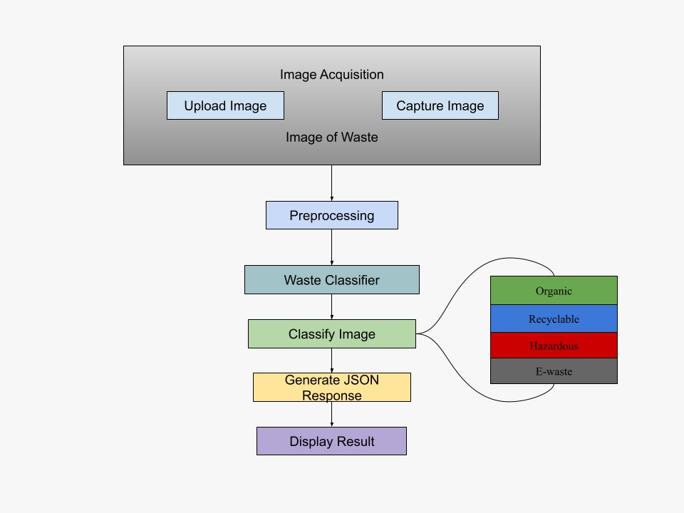
3.1.1 E-R Diagram

3.1.2 DFDs
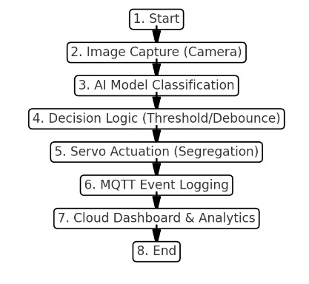

4. Scheduling and Estimates
Total Project Duration: 12–14
- Week 1–2: Literature review, existing solutions, feasibility study.
- Week 3–4: Dataset creation, augmentation, and preprocessing.
- Week 5–6: Model development, training, and hyperparameter tuning.
- Week 7: Building smart bin hardware with servo integration.
- Week 8: MQTT setup, cloud backend integration.
- Week 9–10: Dashboard UI and analytics.
- Week 11: Testing, debugging, and optimization.
- Week 12: Final deployment and documentation.
- Week 13–14: Enhancements, scalability tests, and patent preparation. The schedule allows ample time for testing, integration, and improvements.

